# Software Design Specification

**Movie Theatre Ticketing System (MTTS)**

**Team Members:**  
 Julio Nevarez  
 Matthew Kloth  
 Doan Quoc Tien Nguyen  
 Jingyi Chen

## System Description

The Movie Theatre Ticketing System (MTTS) is designed to optimize the management and sale of movie tickets, offer an intuitive interface for customers to acquire tickets, and incorporate administrative features for theatre personnel to oversee showtimes, access transaction history, and produce sales reports. The system seeks to provide a seamless experience for customers and theatre personnel, incorporating features like real-time seat availability, adaptable payment methods, and comprehensive show details.

## Software Architecture Overview

**SWA Diagram**

## Software Architecture Diagram Description

The software architecture for the **Movie Theatre Ticketing System (MTTS)** is structured into distinct layers that manage different functionalities, interactions, and data flow. The architecture can be divided into the following main components:

**1. User Interface Layer**

The User Interface Layer consists of various pages that provide an interactive experience for users and administrators. These pages capture user input, display system information, and initiate requests to the backend for data and operations. Pages include:

* **Login Page**: Handles user authentication, allowing existing users to log in and new users to navigate to the Registration Page.
* **Registration Page**: Manages new user registration by capturing details such as username, password, and contact information.
* **Movie Selection Page**: Displays available movies for users to choose from and requests movie listings from the backend.
* **Theatre and Showtime Page**: Shows detailed information about showtimes and theatre locations for selected movies.
* **Seat Selection Page**: Allows users to select available seats for a chosen showtime and sends seat selection data to the backend.
* **Payment Page**: Collects payment details, applies rewards or discounts, and initiates payment processing.
* **Confirmation Page**: Displays a summary of the completed booking and sends confirmation details to the user.

The Admin Page serves as a specialized interface for administrative users, providing access to generate reports, update showtimes, and manage the theatre’s backend data.

**2. Backend Application Layer**

The Backend Application Layer is responsible for processing the logic, managing data transactions, and coordinating operations across different modules. This layer includes various **managers** that handle specific parts of the system:

* **User Manager**: Manages user authentication, registration, profile updates, and rewards status. It interacts with the User Database and the Rewards Manager to update user rewards and apply discounts.
* **Movie Manager**: Handles requests for movie listings and communicates with the Movie Database to fetch or update movie details.
* **Showtime Manager**: Manages showtimes for movies and updates theatre schedules. Interacts with the Showtime Database.
* **Seat Manager**: Manages seat availability for different showtimes, updating status when seats are reserved or released. Communicates with the Showtime Database.
* **Payment Processor**: Facilitates payment processing through an external Payment Gateway and updates the Booking Database with transaction details. It also works with the Rewards Manager to apply any rewards-based discounts or point updates during a transaction.
* **Rewards Manager**: Manages rewards information, including point accumulation, discount application, and user-specific reward updates. It communicates with the User Manager to display reward status and with the Payment Processor to apply discounts and update points after successful transactions.
* **Report Generator (Admin Only)**: Allows administrators to generate booking, sales, and performance reports by fetching data from the Booking Database.

The **Email Notification System** is integrated into this layer as a notification handler, responsible for sending automated emails triggered by various backend managers, such as the Payment Processor and Rewards Manager.

**3. Database Layer**

The Database Layer stores all persistent data and ensures data integrity across the system. It includes:

* **User Database**: Contains user profiles, credentials, purchase history, and rewards status.
* **Movie Database**: Stores movie details, including titles, genres, and ratings.
* **Showtime Database**: Manages data related to showtimes, theatre locations, and seat availability.
* **Booking Database**: Keeps track of confirmed bookings, seat reservations, and transaction details.
* **Rewards Database**: Maintains information on user rewards, accumulated points, and available discounts.

Each manager in the backend layer communicates with the corresponding database using data requests and responses to perform operations such as Create, Read, Update, Delete.

The Rewards Database is accessed by the Rewards Manager to store and retrieve user-specific rewards data, such as points earned and discounts applied.

**4. External Systems Layer**

The External Systems Layer integrates the MTTS with third-party services to enable additional functionality:

* **Payment Gateway**: An external service that validates and processes user payments. The Payment Processor communicates with the gateway to send payment requests and receive confirmations.
* **Email Notification System**: An external component responsible for sending transactional emails, such as booking confirmations, payment receipts, and rewards updates. The Payment Processor, Rewards Manager, and Confirmation Page send triggers to the Email Notification System to notify users of completed transactions, rewards status changes, and booking confirmations.

Each external system is represented as a separate component and uses secure communication channels to ensure data integrity and privacy.

**5. Data Flow and Communication**

The data flow in the system is facilitated using a combination of user interactions, data requests/responses, and external communications:

1. **User Interactions (Solid Lines)**: These represent direct interactions between the user and the UI pages as they navigate through the system.
2. **Data Requests/Responses (Dashed Lines)**: Backend managers communicate with databases and the UI components using these lines to handle data operations, including rewards management and seat availability checks.
3. **External Communications (Dotted Lines)**: Represent interactions with external systems, such as the Payment Gateway and Email Notification System, for secure payment processing and email notifications.

**6. Architectural Considerations**

* **Modularity**: Each component operates independently, allowing for easy updates or replacements.
* **Scalability**: The architecture can accommodate additional features or modifications without disrupting existing functionalities.
* **Security**: Sensitive data like user credentials and payment information is handled through secure communications with the User Manager and Payment Gateway.
* **Maintainability**: The clear separation of responsibilities between managers and UI components simplifies debugging and future extensions.

This architecture provides a robust foundation for the Movie Theatre Ticketing System, ensuring a seamless experience for both users and administrators while supporting advanced features like rewards and email notifications.

2. UML Class Diagram: Provide detailed class structures, attributes, and operations.

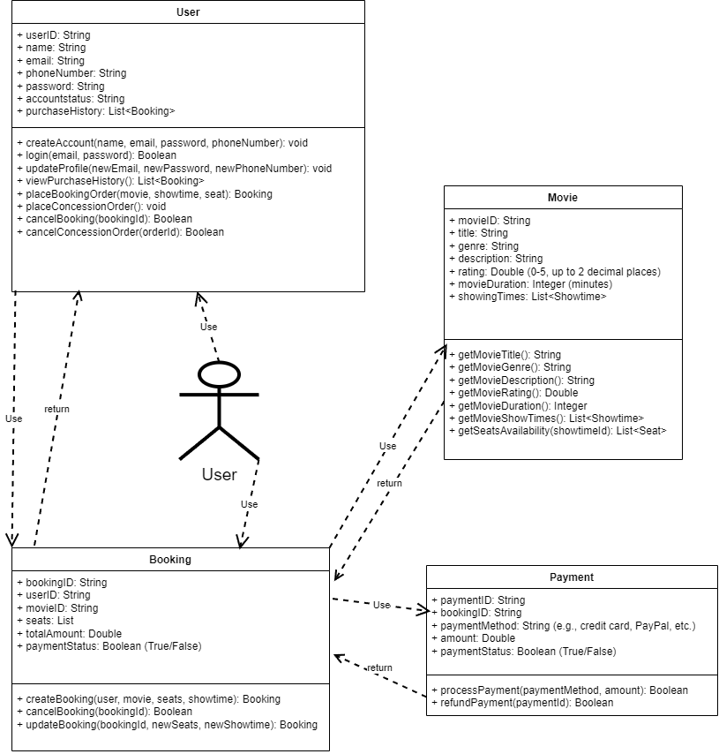

3. Class Descriptions:

**- Class User:** Represents a customer that uses the system to book movie tickets and manage their account. It lets the user manage their profile, interact with booking and rewards, and place concession orders.

**- Attributes:**

* userID: String - A unique identifier for each user.
* name: String - The user's full name (first and last name).
* email: String - The user's email address, used for account login and notifications.
* phoneNumber: String (Optional) - User's phone number for notifications and optional two-factor authentication.
* password: String - Password for the user’s account.
* accountStatus: String - Account status, which could be "active," "inactive," or "suspended."
* purchaseHistory: List<Booking> - List of bookings made by the user, including past ticket purchases and concessions.

**- Operations:**

createAccount(name: String, email: String, password: String, phoneNumber: String?): void

* Creates a new account with an optional phone number.

login(email: String, password: String): Boolean

* Authenticates the user by checking the email and password.

updateProfile(newEmail: String, newPassword: String, newPhoneNumber: String?): void

* Allows the user to update their account details such as email, password, and phone number.

viewPurchaseHistory(): List<Booking>

* Retrieves the list of the user's past bookings and purchases.

placeBookingOrder(movie: Movie, showtime: Showtime, seat: Seat): Booking

* Allows the user to place an order for a movie ticket with a selected showtime and seat.

placeConcessionOrder(orderItems: List<ConcessionItem>): void

* Allows the user to order items from the concession stand.

cancelBooking(bookingID: String): Boolean

* Cancels a booking if the movie has not started and the ticket has not been used.

cancelConcessionOrder(orderID: String): Boolean

* Cancels a concession order if the items have not been picked up.

**- Class Movie:** Represents the details of each individual movie. It contains information like the movie's title, genre, description, and ratings. It is linked to the showtimes and seat availability for the movie.

**- Attributes:**

* movieID: String - A unique identifier for each movie.
* title: String - The title of the movie.
* genre: String - The genre of the movie (e.g., Action, Comedy, Drama).
* description: String - A brief summary of the movie.
* rating: Double - Audience rating on a scale from 0 to 5 with two decimal places.
* movieDuration: Integer - The duration of the movie in minutes.
* showingTimes: List<Showtime> - A list of available showtimes for the movie.

**- Operations:**

getMovieTitle(): String

* Returns the title of the movie.

getMovieGenre(): String

* Returns the genre of the movie.

getMovieDescription(): String

* Returns the description of the movie.

getMovieRating(): Double

* Returns the audience rating for the movie.

getMovieDuration(): Integer

* Returns the duration of the movie in minutes.

getMovieShowTimes(): List<Showtime>

* Returns the list of available showtimes for the movie.

getSeatsAvailability(showtimeID: String): List<Seat>

* Checks and returns the availability of seats for the given showtime.

**- Class Booking:** Manages the ticket booking process for users. It records the user’s selected movie, showtime, seats, and payment status. It also allows users to cancel or update their bookings.

**- Attributes:**

* bookingID: String - A unique identifier for each booking.
* userID: String - The unique identifier of the user who made the booking.
* movieID: String - The unique identifier of the movie being booked.
* seats: List<Seat> - The list of seats that the user has selected for the booking.
* totalAmount: Double - The total amount to be paid for the booking.
* paymentStatus: Boolean - Indicates whether the payment has been confirmed (True) or declined (False).

**- Operations:**

createBooking(user: User, movie: Movie, seats: List<Seat>, showtime: Showtime): Booking

* Creates a new booking for the user with the selected movie, seats, and showtime.

cancelBooking(bookingID: String): Boolean

* Cancels an existing booking and refunds the user if applicable.

updateBooking(bookingID: String, newSeats: List<Seat>, newShowtime: Showtime): Booking

* Allows the user to update the seats or showtime for an existing booking.

**- Class Payment:** Handles the payment process for bookings. It processes the user's payment and stores payment information, including the payment method and status on if the payment has been processed or not.

**- Attributes:**

* paymentID: String - A unique identifier for the payment.
* bookingID: String - The unique identifier for the booking associated with the payment.
* paymentMethod: String - The method used for payment (e.g., Credit Card, PayPal).
* amount: Double - The total amount paid for the booking.
* paymentStatus: Boolean - Indicates whether the payment has been processed successfully (True) or failed (False).

**- Operations:**

processPayment(paymentMethod: String, amount: Double): Boolean

* Processes the payment and returns True if successful or False if declined.

refundPayment(paymentID: String): Boolean

* Issues a refund to the user based on the provided paymentID and returns True if the refund is successful.

## Development Plan and Timeline

1. Partitioning of Tasks: List of tasks and their estimated timeline.

2. Team Member Responsibilities: Which team member is responsible for each task.